Groundwater project report contents
- Describing Uhlirska catchment site (precipitation amounts, geology, topography, land cover, soils, aquifer)
- Short description of Modflow program and GWVistas software (use web with citations)
- Design of Uhlirska Model in Modflow/GWVistas – one layer, how many rows and columns, local coordinates, infiltration=recharge of aquifer (BFlow baseflow analysis from excel), rivers, top elevation, bottom elevation, hydraulic conductivity map
- Calibration of the steady state model using piezometer heads and other supporting points of groundwater table (hilly parts), describe procedure of calibration (manual, automatic GV calibration), results (figure or table)
- Optional bonus, use of Modpath and particles from the hilly parts towards the valleys
- Figures – map of catchment, map of top elevation, bottom elevation, groundwater table with velocity vectors, map of hydraulic conductivity, calibration map with targets (circles of calibration), crossplot of measure and modelled groundwater heads
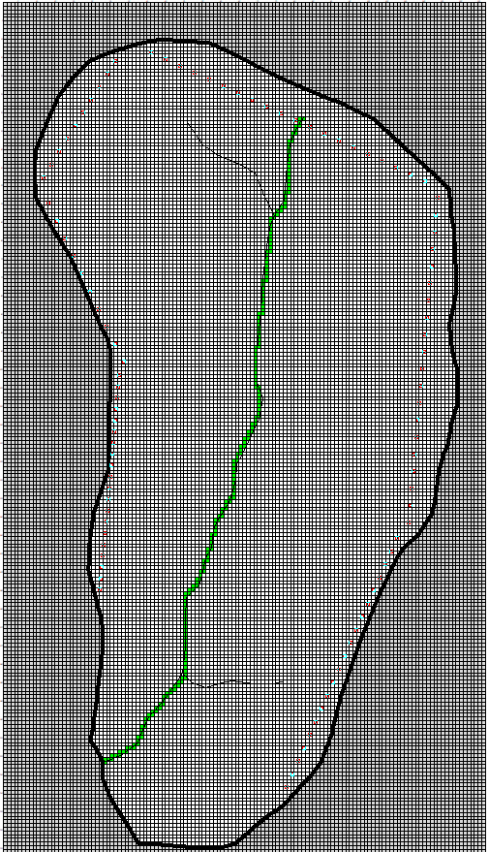
Fig. xx-number yourselve Map of finite differences and streams in the model

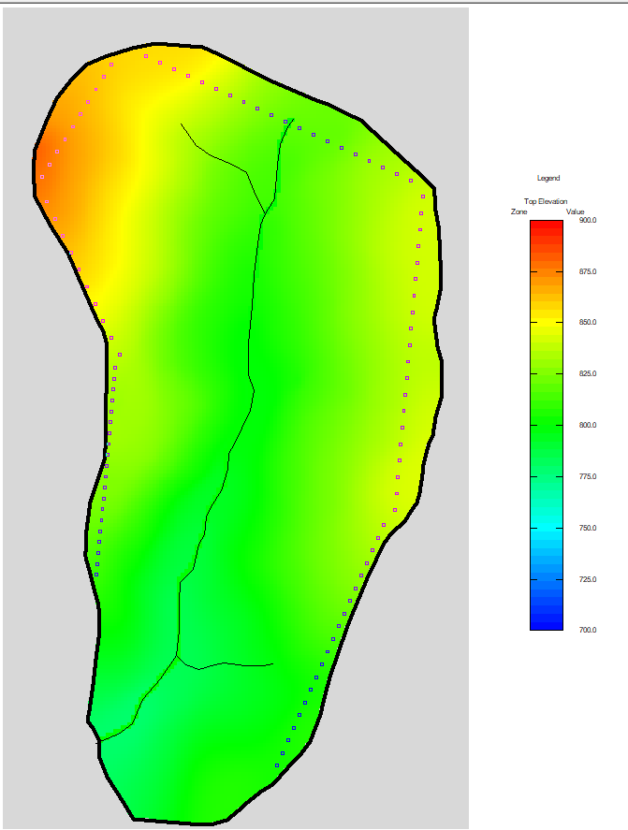
Fig. xx-number yourselve Map of top elevation

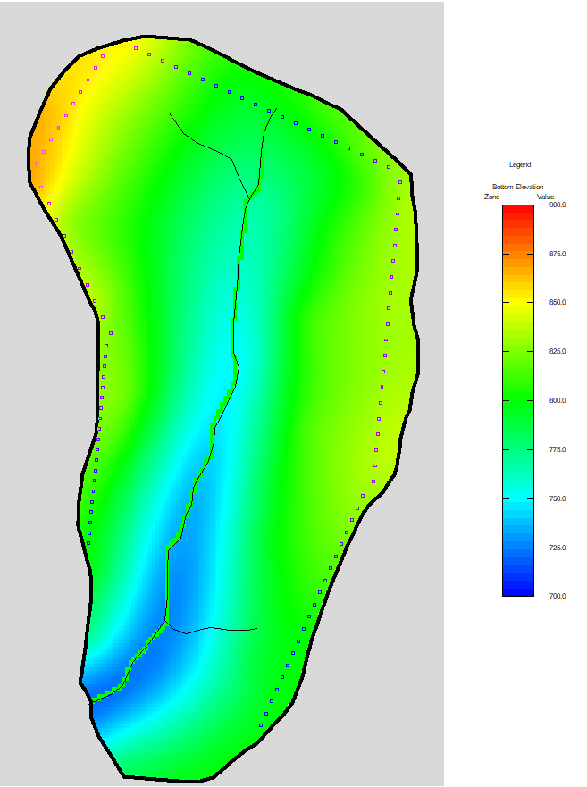
Fig. xx-number yourselve Map of bottom elevation

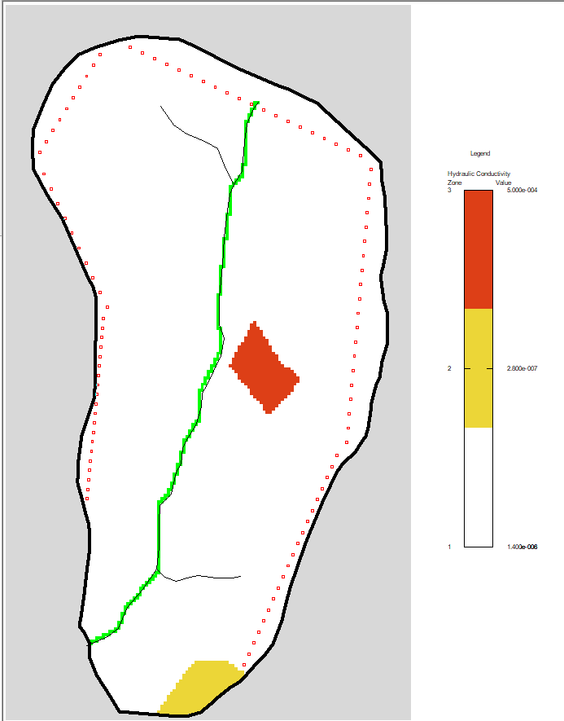
Fig. xx-number yourselve Map of saturated hydraulic conductivity zones
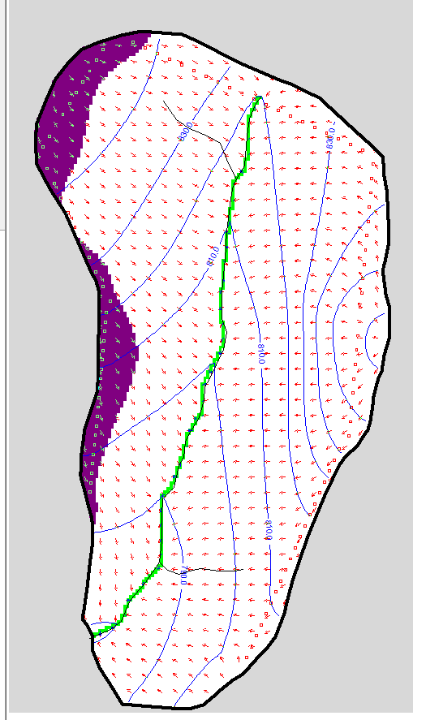
Fig. xx-number yourselve Map of modelled water table and velocity vectors

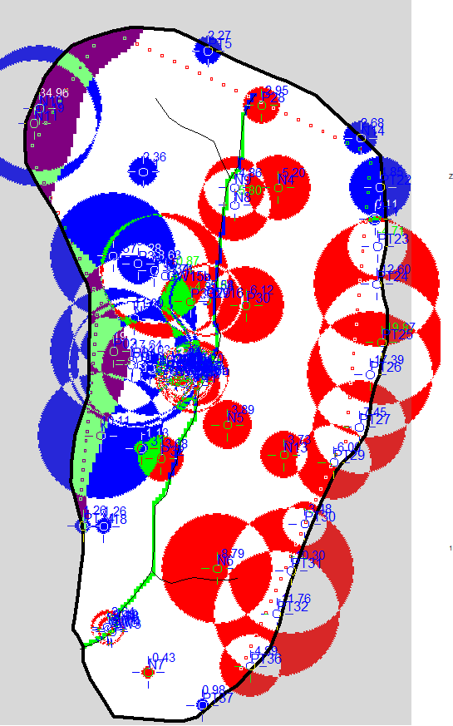
Fig. xx-number yourselve Map of calibration results

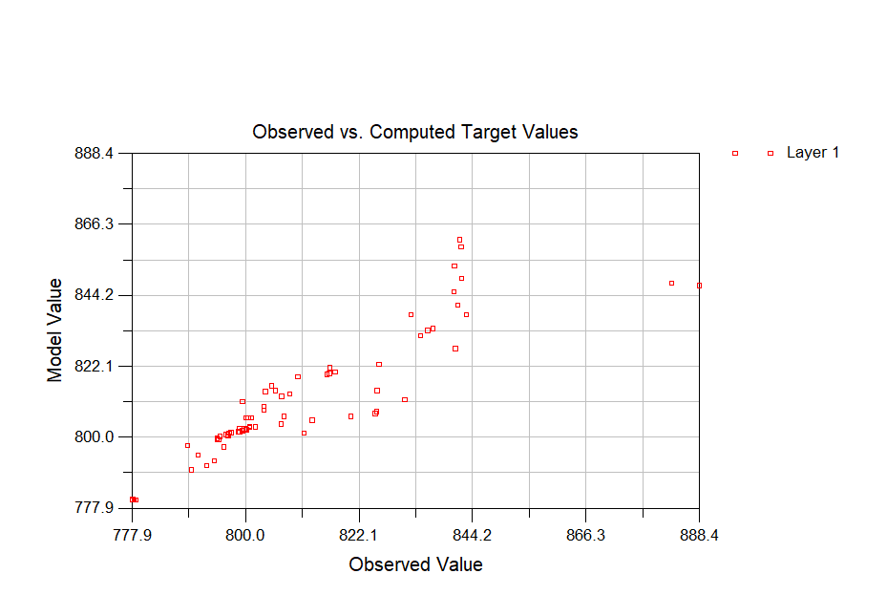
Fig. xx-number yourselve Modeled and observed values of groundwater

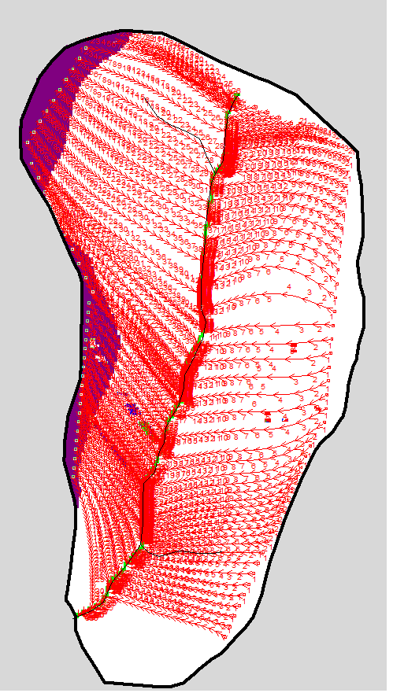
Fig. xx-number yourselve Map of pathlines and traveltimes (years)..use Props – porosity 0.01

Conclusion
Results comments. Your experience with modelling

